Test Case: tc006_SPX_Dev5_Crear_Requisicion_Spot_Tipo_Cobro_Proyect_Urgent
Step 1 - Enter username and password and click to button Enter: Credentials Entered
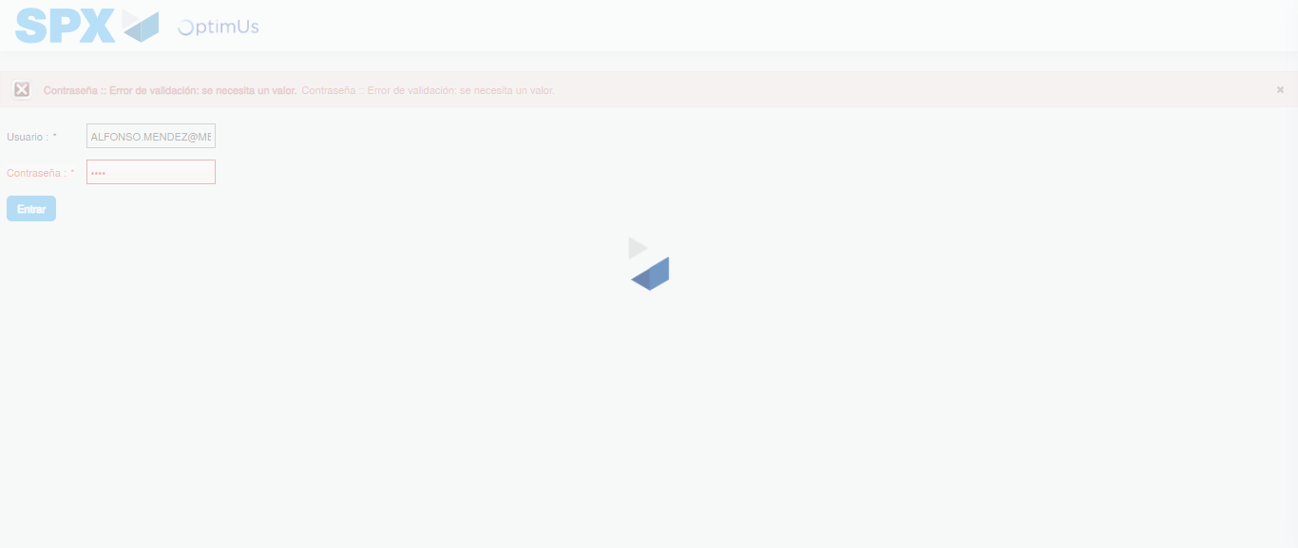Image file-name: QC_Testing-tc006_SPX_Dev5_Crear_Requisicion_Spot_Tipo_Cobro_Proyect_Urgent-1783373458861

Step 2 - Select to UEN and Access to Spot Buy Requisitions : UEN Correctly selected and Correct access
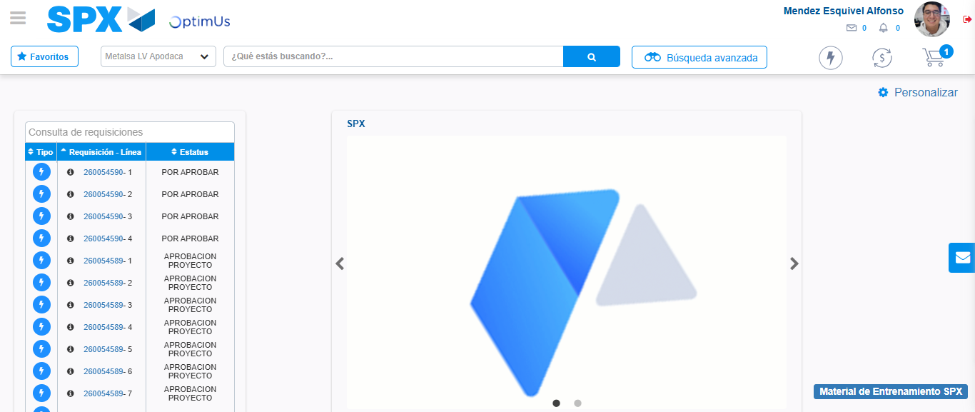Image file-name: QC_Testing-tc006_SPX_Dev5_Crear_Requisicion_Spot_Tipo_Cobro_Proyect_Urgent-1783373543783

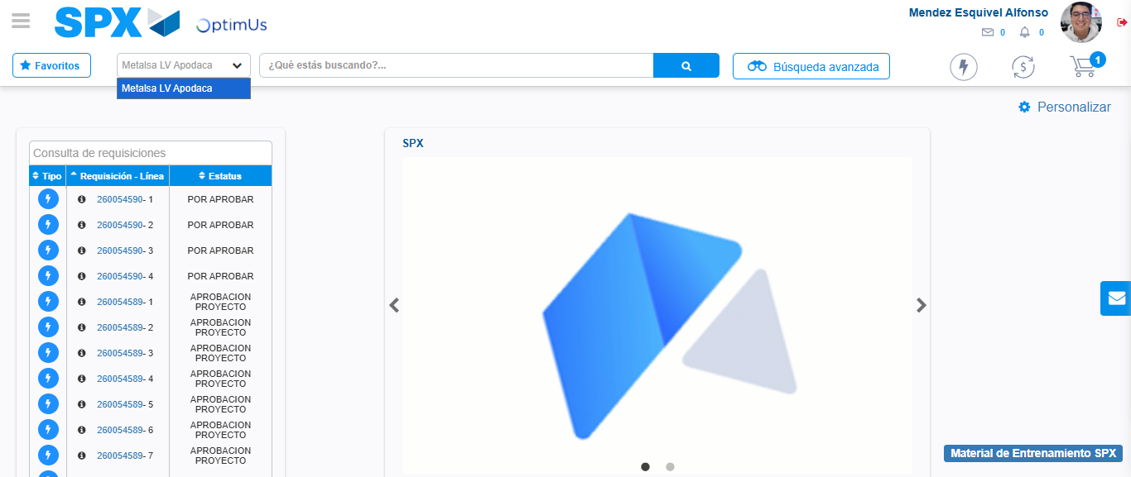Image file-name: QC_Testing-tc006_SPX_Dev5_Crear_Requisicion_Spot_Tipo_Cobro_Proyect_Urgent-1783373546281

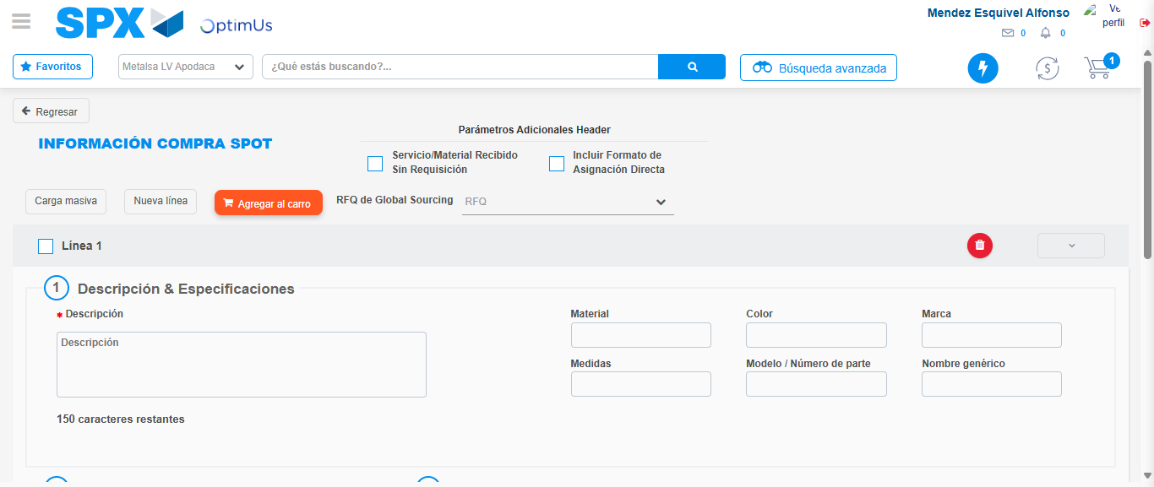Image file-name: QC_Testing-tc006_SPX_Dev5_Crear_Requisicion_Spot_Tipo_Cobro_Proyect_Urgent-1783373558659

Step 3 - Data Capture Spot Buy Requisition: Data captured correctly
Image file-name: QC_Testing-tc006_SPX_Dev5_Crear_Requisicion_Spot_Tipo_Cobro_Proyect_Urgent-1783373558902

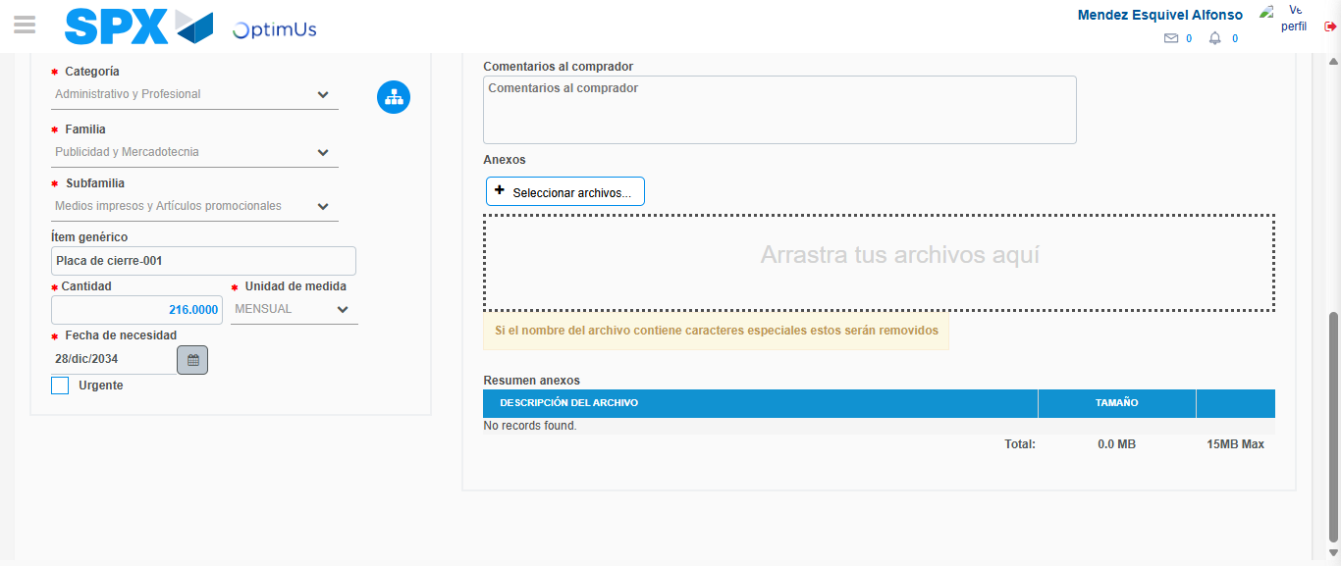Image file-name: QC_Testing-tc006_SPX_Dev5_Crear_Requisicion_Spot_Tipo_Cobro_Proyect_Urgent-1783373569676

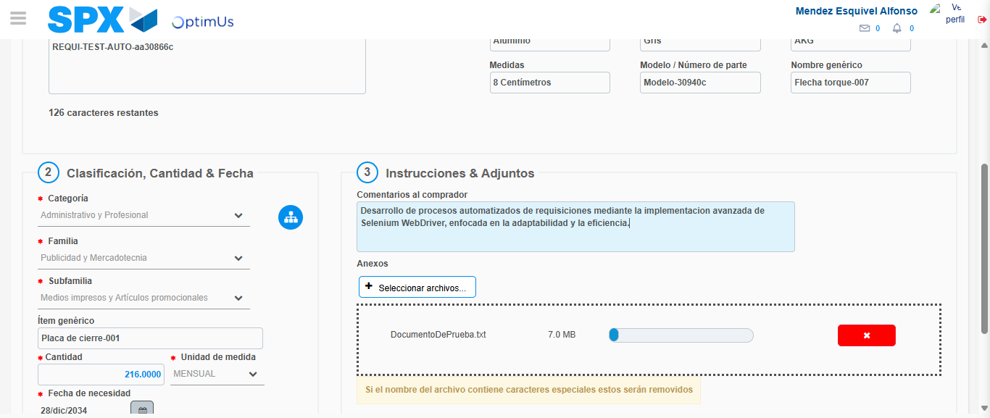Image file-name: QC_Testing-tc006_SPX_Dev5_Crear_Requisicion_Spot_Tipo_Cobro_Proyect_Urgent-1783373570418

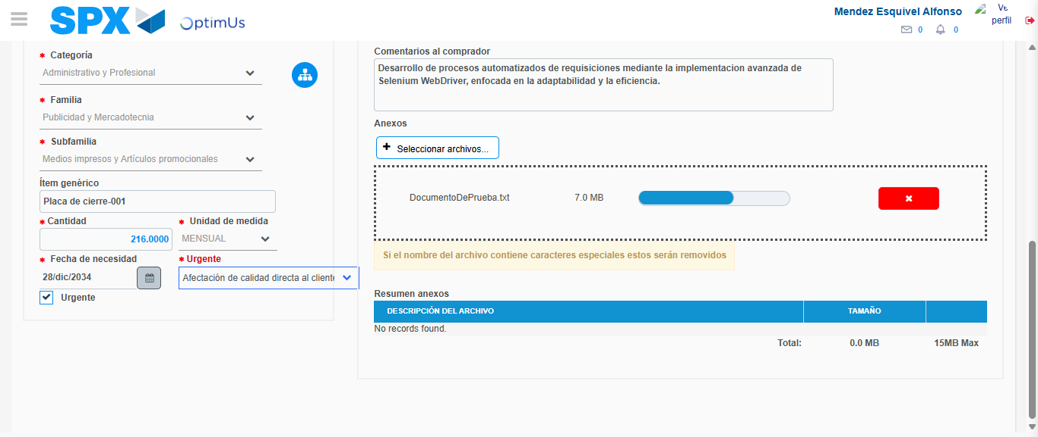Image file-name: QC_Testing-tc006_SPX_Dev5_Crear_Requisicion_Spot_Tipo_Cobro_Proyect_Urgent-1783373574133

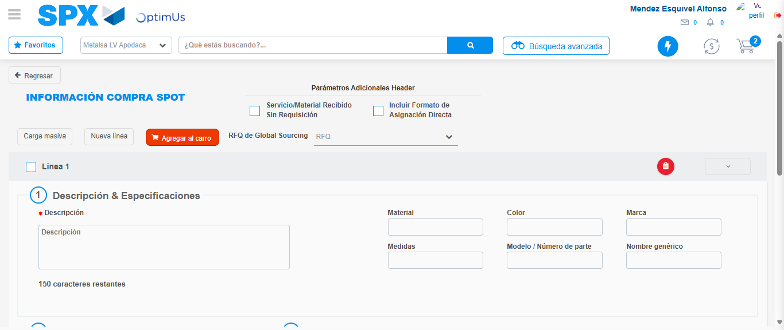Image file-name: QC_Testing-tc006_SPX_Dev5_Crear_Requisicion_Spot_Tipo_Cobro_Proyect_Urgent-1783373581577

Step 7 - Return to Main Page SPX : Return to Main Page SPX
Image file-name: QC_Testing-tc006_SPX_Dev5_Crear_Requisicion_Spot_Tipo_Cobro_Proyect_Urgent-1783373543783

Image file-name: QC_Testing-tc006_SPX_Dev5_Crear_Requisicion_Spot_Tipo_Cobro_Proyect_Urgent-1783373546281

Image file-name: QC_Testing-tc006_SPX_Dev5_Crear_Requisicion_Spot_Tipo_Cobro_Proyect_Urgent-1783373558659

Image file-name: QC_Testing-tc006_SPX_Dev5_Crear_Requisicion_Spot_Tipo_Cobro_Proyect_Urgent-1783373583814

Image file-name: QC_Testing-tc006_SPX_Dev5_Crear_Requisicion_Spot_Tipo_Cobro_Proyect_Urgent-1783373583988

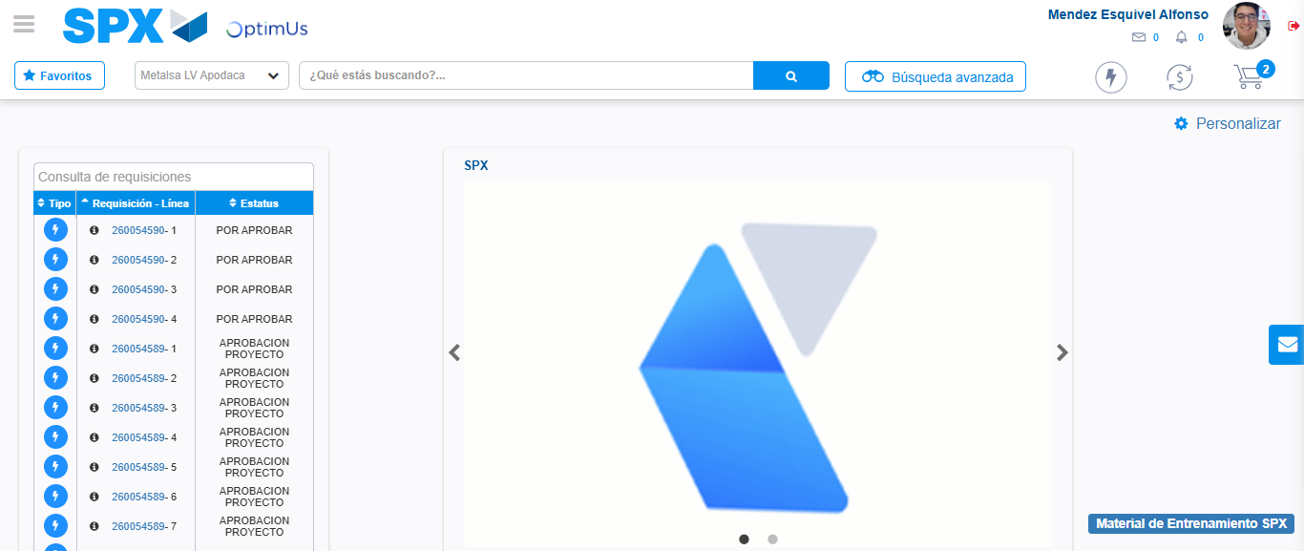Image file-name: QC_Testing-tc006_SPX_Dev5_Crear_Requisicion_Spot_Tipo_Cobro_Proyect_Urgent-1783373604992

Step 8 - Log Out : Log Out SPX
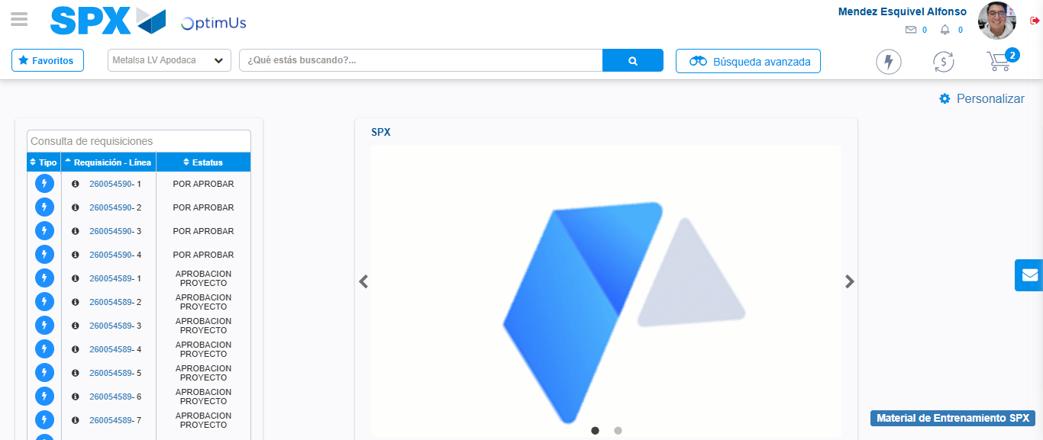Image file-name: QC_Testing-tc006_SPX_Dev5_Crear_Requisicion_Spot_Tipo_Cobro_Proyect_Urgent-1783373605234

